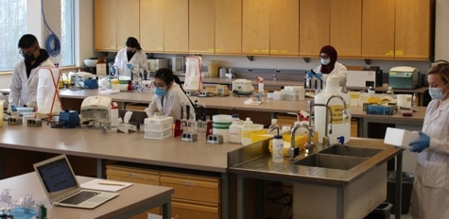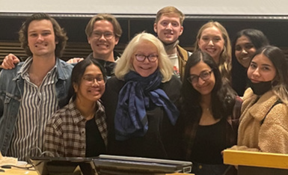~ Free food and refreshments ~

~ Peruse our unique courses and tour our labs ~

~ Learn about research and career opportunities ~

~ Meet MBB students and instructors ~

**We hope to see you soon!**